

**Project**

**Project**

**on**

**Car Simulating System**

**BACHELORS OF SCIENCE(INFORMATION TECHNOLOGY**

***Submitted by:-***

***Tanishq Singh***

***Shamsher Singh Bhandari***

***03-06-2021***

***Content***

Bona Fide

Acknowledgement

* 1 Introduction
  + Credits
  + Overview
* Part List
  + Servo Drive
  + Servo
    - * Tested Motors
      * Ordering MiGE Servo
  + Clamping Set
    - * Beano’s Universal Clamping Set
      * Standard Clamping Set and Adapter
      * 3D-printed Clamping Set
  + Quick Release
  + 24V Power Supply
  + STM32F4DISCOVERY Controller
  + Adapter Board
  + USB to RJ45 Adapter
  + Cables & Electronic Accessories
  + Braking Resistor
  + Servo Mounting Bracket
  + Example Ordering List
* Hardware Setup
  + General Wiring
  + Disco
* Software Setup
  + General Information
  + Required Software
* Granity
  + STM32 ST-LINK utility
  + MMos FFB Tool
  + Granity – PWM
  + Uninstalling vJoy
  + Improving Performance
* Granity Settings
* Tuning Torque Controller
* Disco Adapter Board Connections

**BONA FIDE CERTIFICATE**

This is to certify that “Tanishq Singh” and “Shamsher Singh Bhandari” students of “BSc-IT” have successfully completed their Project on “Car Simulating System” under the guidance of “Mrs. Anupriya Sharma Ghai”.

Mrs. Anupriya Sharma Ghai Tanishq Singh

Shamhser Singh Bhandari

ACKNOWLEDGEMENT

I would like to express my special thanks of gratitude to my teacher Mrs. Anupriya Sharma Ghai, who gave me the golden opportunity to this wonderful project of “Car Simulating System”.

Secondly I would like to express my thanks to my parents and friends who helped me a lot in finalizing this project within the limited time frame.

Tanishq Singh

Shamsher Singh Bhandari

BSC-IT(6th Sem)

**1 Introduction**

**1.1 Credits**

The idea of this project was ordinated Shamsher Singh Bhandari and Tanishq Singh. Another essential part, the USB HID Controller2 , is developed by the user "MMos". A lot of effort on the electronical side has been done. With his developments, the amount of work of building oneself an OpenSimwheel is reduced immensely. With a continuously growing user-base there are more and more helpful individuals sharing knowledge and information. I can’t name everyone in person, but a big thanks to all of you! Be it hardware, software, consulting, discussing.

**1.2 Overview**

The OpenSimwheel is an continuously evolving project. This pictures the current state and recommends proven concepts. Never the less it’s of an informative nature only and it’s up to you which parts to choose. An overview of the interconnection between the computer and the servo wheel can be seen in figure.

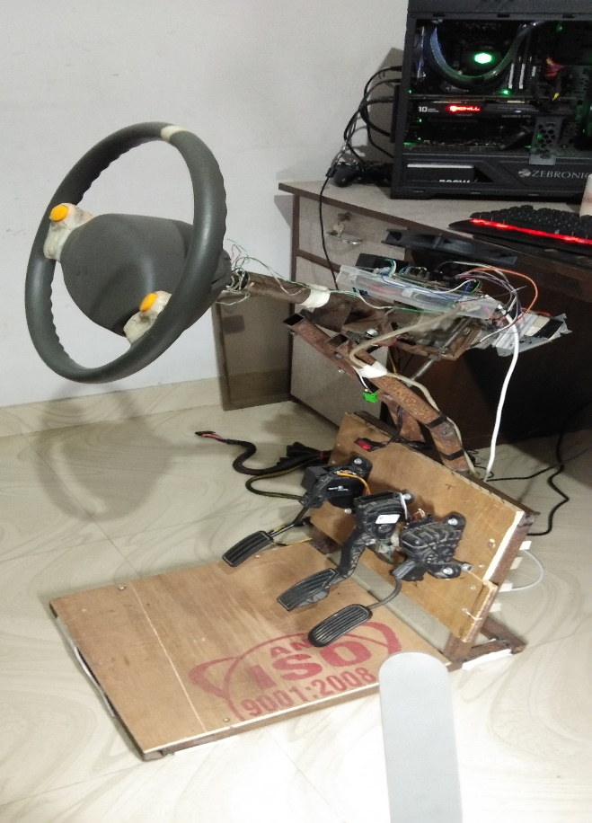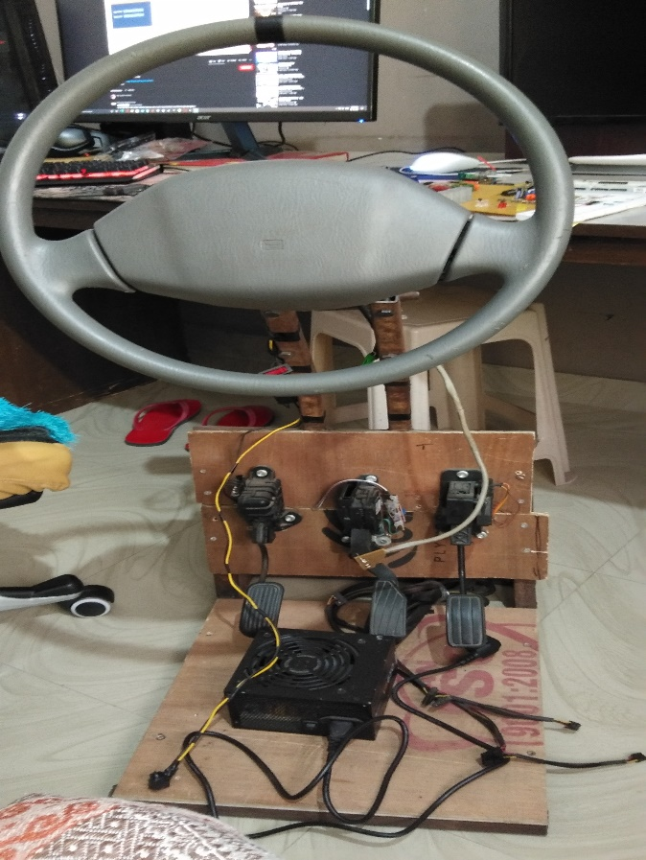

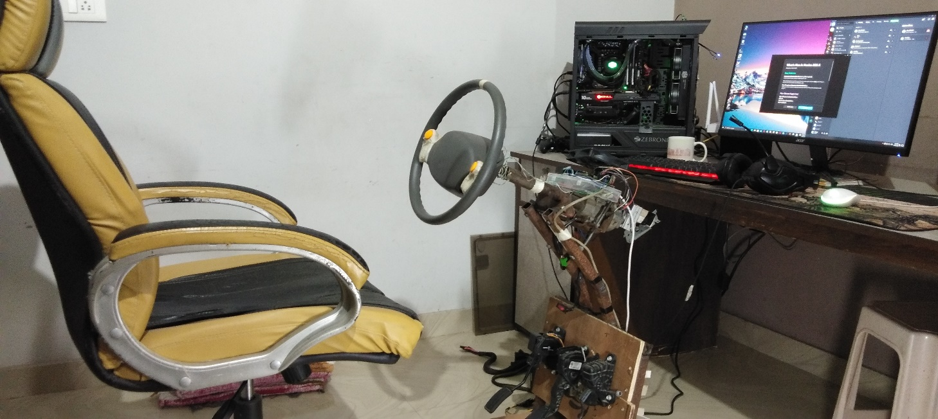

**2 Part List**

This section lists all relevant parts which are essential to build yourself an OpenSimwheel . Most of the parts will have multiple options to choose from. I will recommend components with (in my humble opinion) the best price-performance ratio and present alternatives. Prices are greatly dependent of your location due to individual shipping, tax and duty costs. In section 2.12 is an example ordering list for a complete OpenSimwheel package.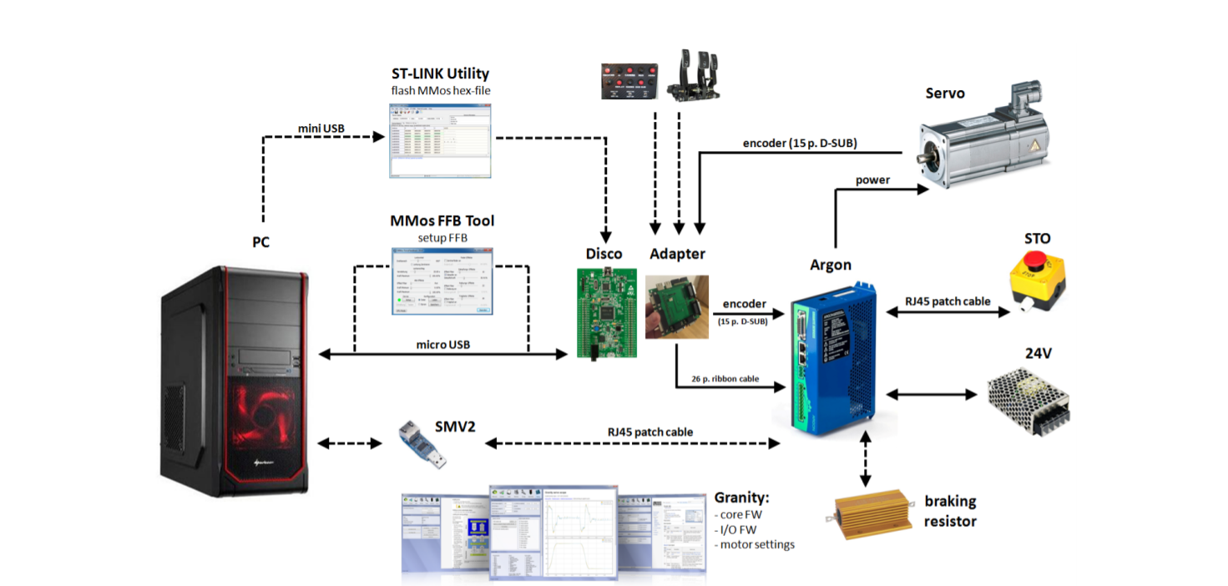

**2.1 Servo Drive**

A Servo Drive is an electronic amplifier to power the servo motor. An excellent drive is the Argon,. Get it directly from their online shop or search for a distributor. There is a very good wiki for this device, too. It’s highly recommended to get four pieces of these heat sinks and a small fan to keep temperatures low.

Alternatively, it’s possible to use the cheaper VSD-E Servo Drive .It’s maximum current is lower, thus producing less torque. Furthermore, an external power supply is needed which has to be considered when comparing prices! The third option will be (not released yet at this time) the IONI servo drive. All servo drives can be seen in figure 2.

**2.2 Servo**

**2.2.1 Tested Motors**

The servos shown in table (1) have been tested and are in use as OpenSimwheel motor.

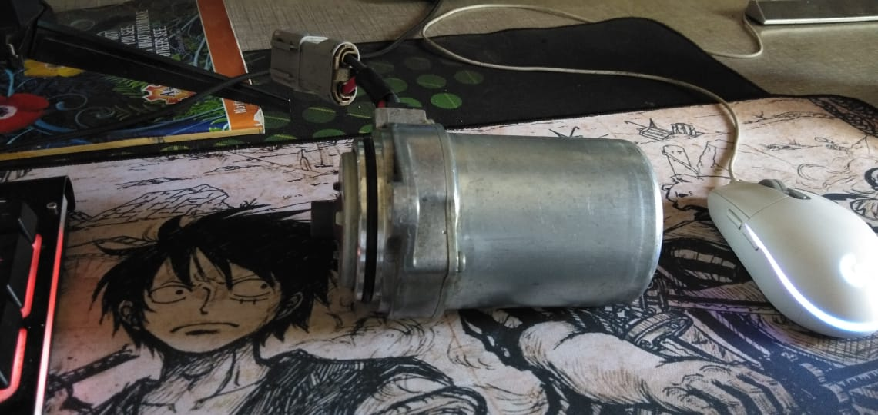

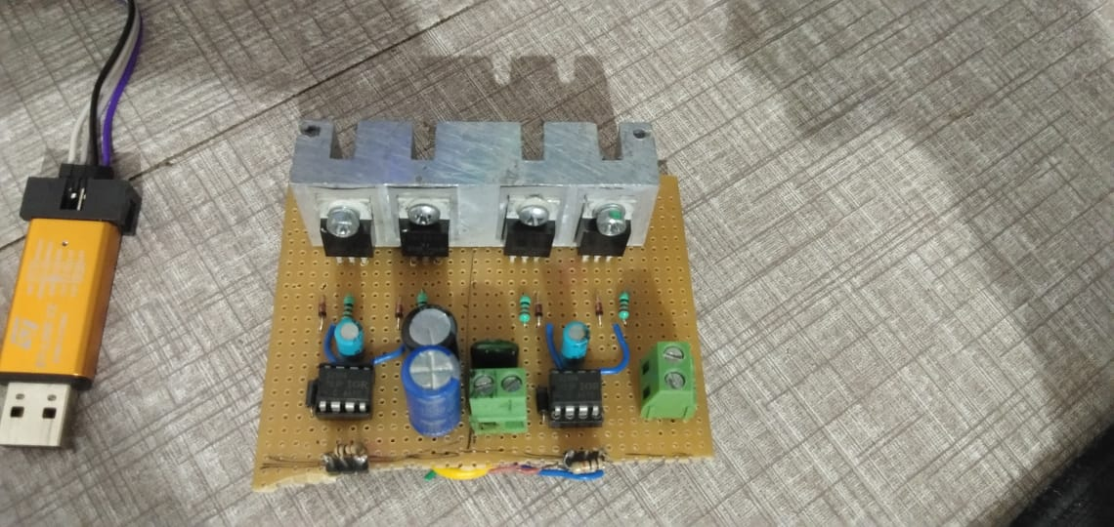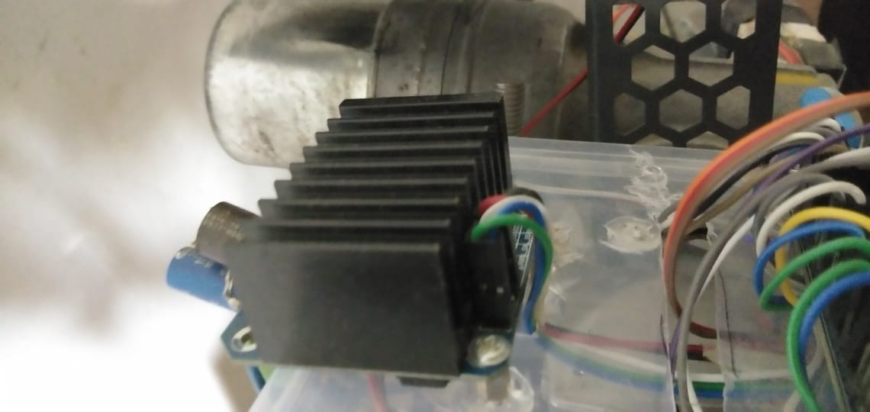

. About equal peak torque level as the big MiGE combined with the least rotor inertia and highest encoder resolution.

**2.3.1 Beano's Universal Clamping Set**

There is a special OpenSimwheel clamping set designed by Beano shown in figure 3. It fits servo shaft diameters of both 19 mm and 22 mm.

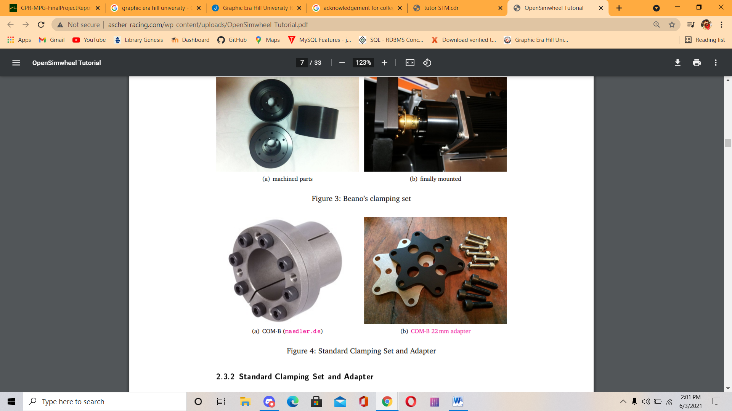

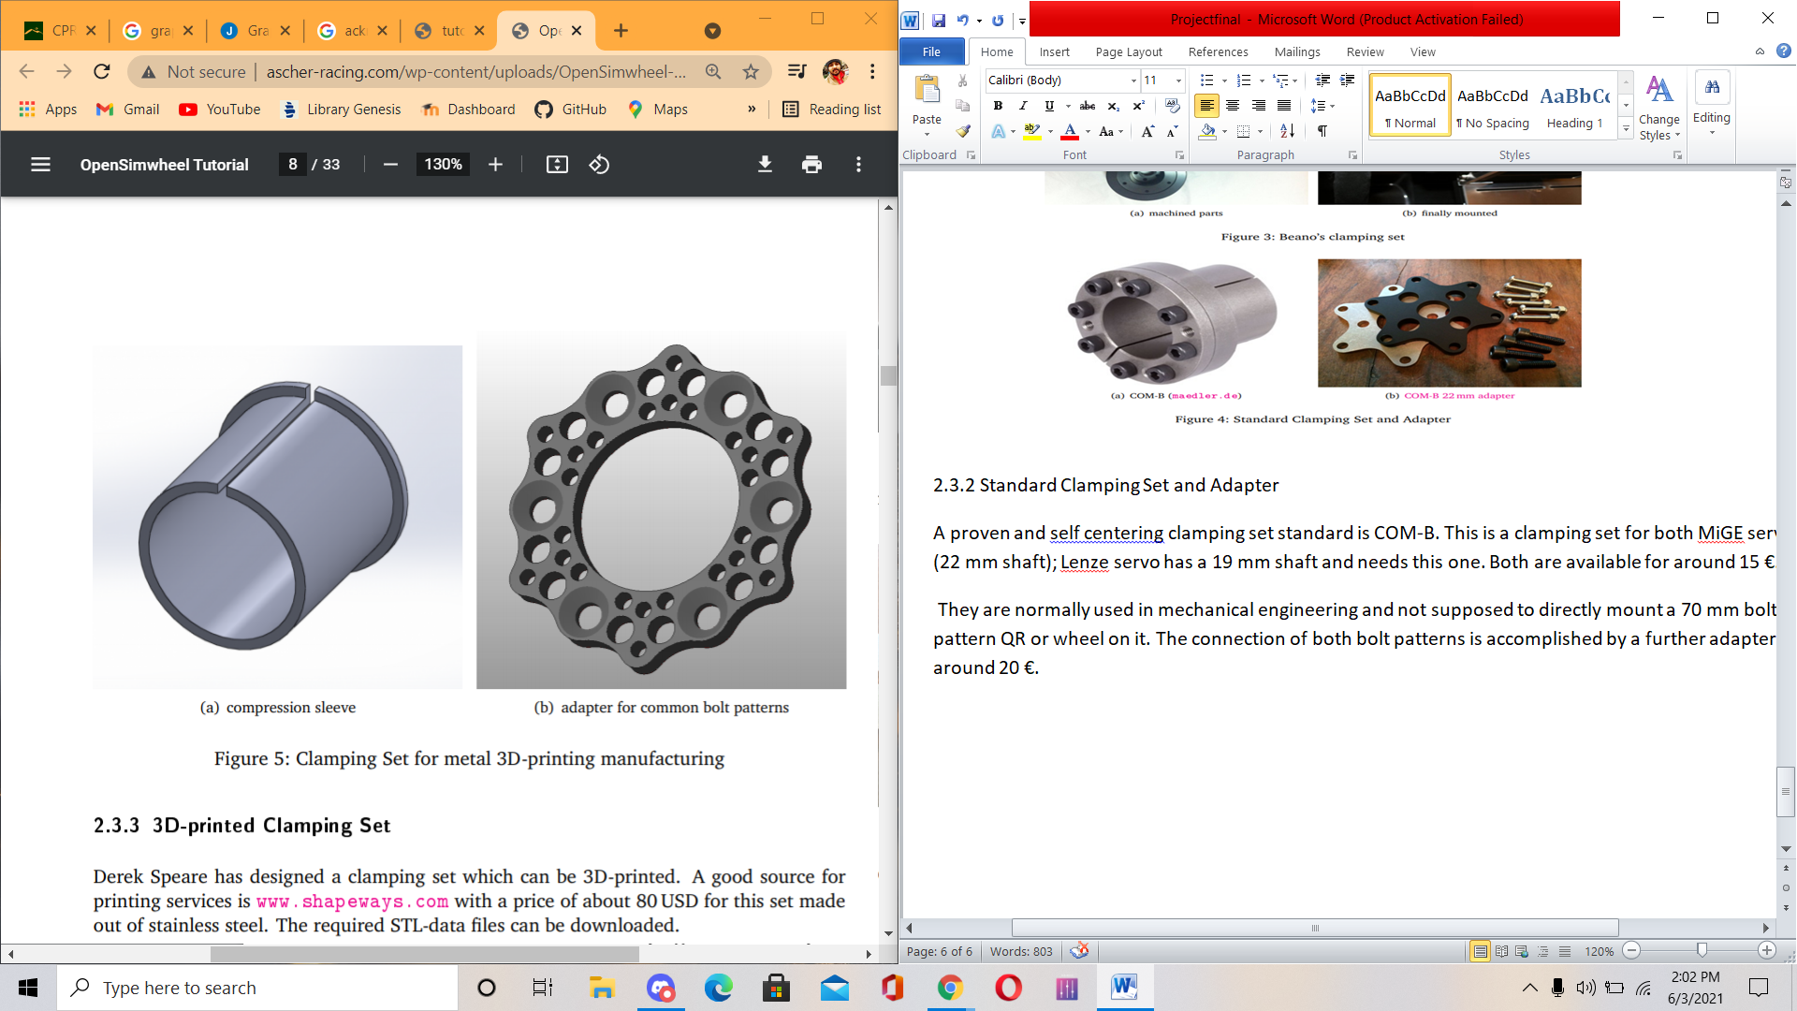

**2.4 Quick Release**

A Quick Release is highly recommended when using multiple wheel rims. Direct drive servo wheels operate not only at high torque levels but also vibrate at a large frequency band. This means that any mechanical play of the quick release system is destructive. Usually, cheap systems always have at least a tiny bit of play which can be enough to screw up the experience. But there is an affordable Quick Release for simracing which is designed to have absolutely zero play at all.

**2.5 24V Power Supply**

12v pc power supply 650 watt.

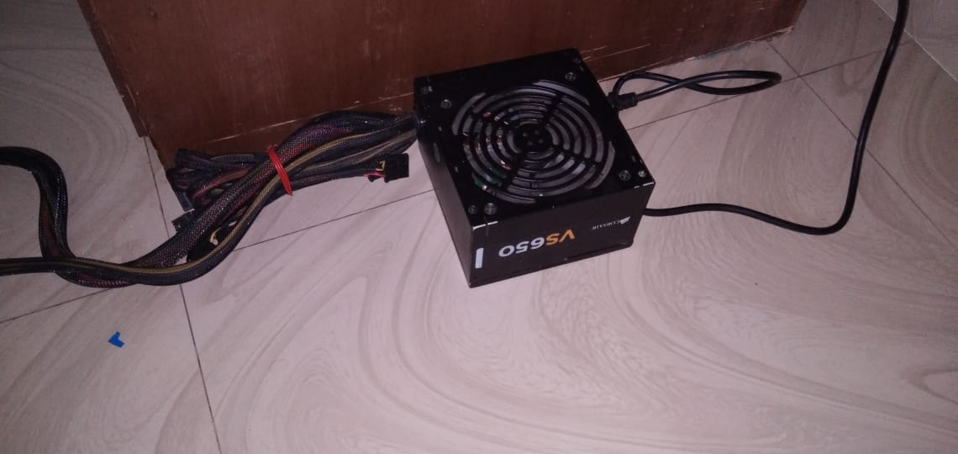

**2.7 Adapter Board**

The connection between the Disco controller board and the Argon is documented in appendix B and can either be wired directly or via an additional adapter board seen in figure 8. It does the same job as wiring everything manually but requires no knowledge about any diagrams and works out of the box.

**2.9 Programmer and microcontroller**

In case you don’t want to build the electronic connection by yourself, Dennis Reimer gives the option to build a complete cable harness for the OpenSimwheel .

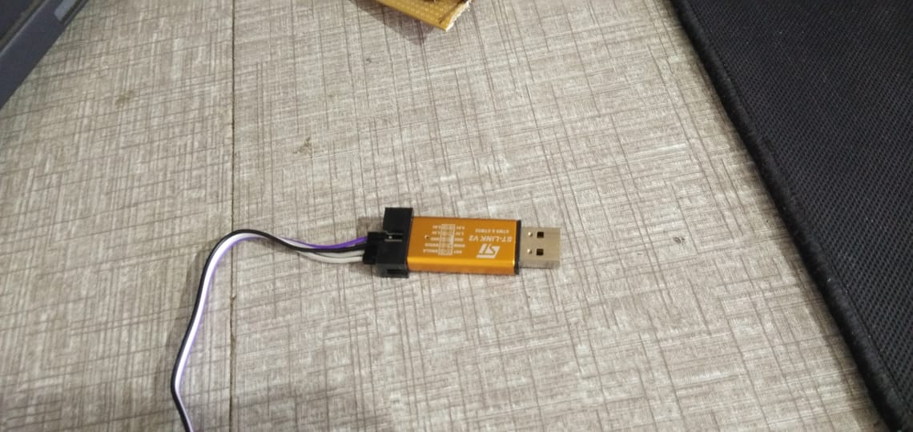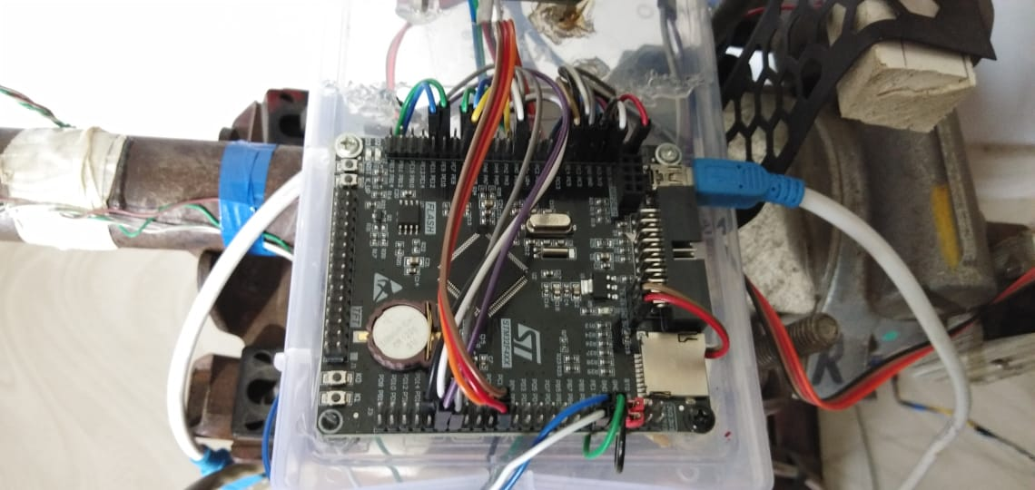

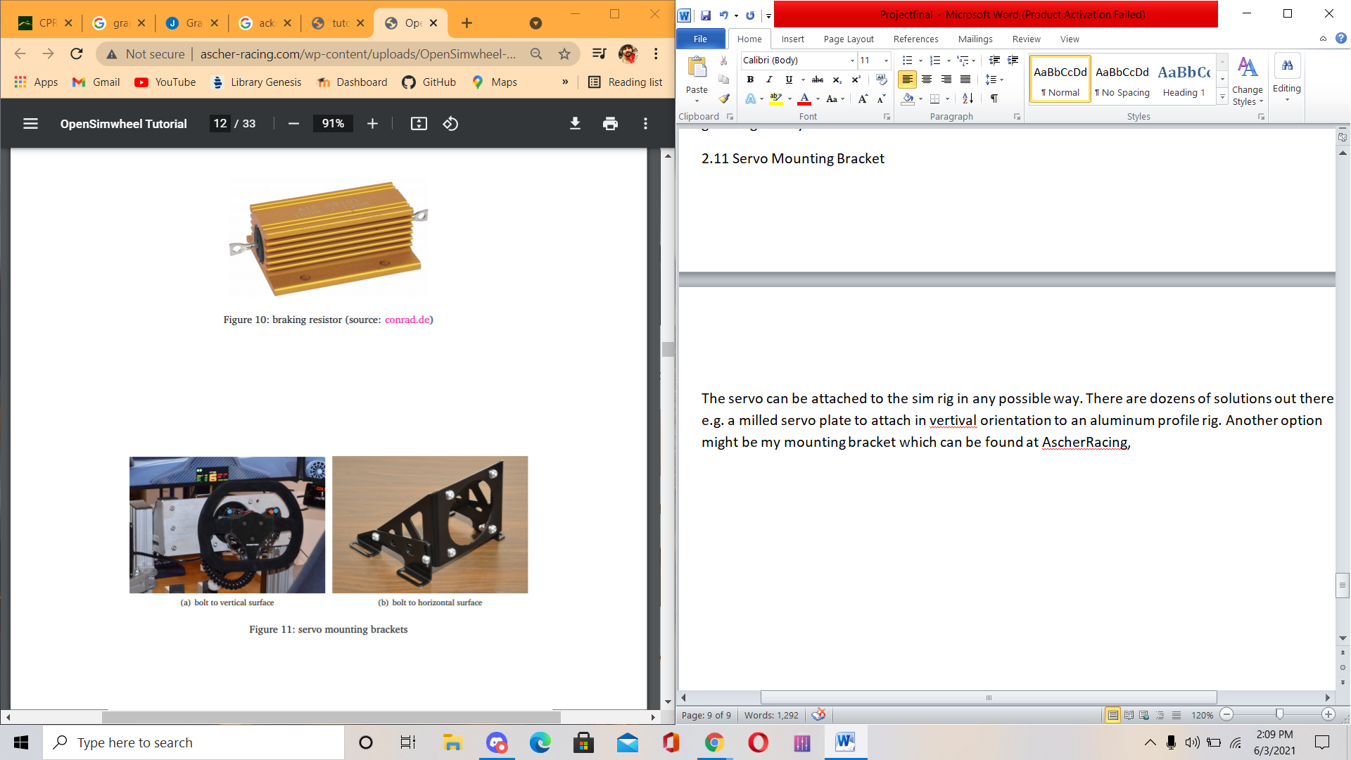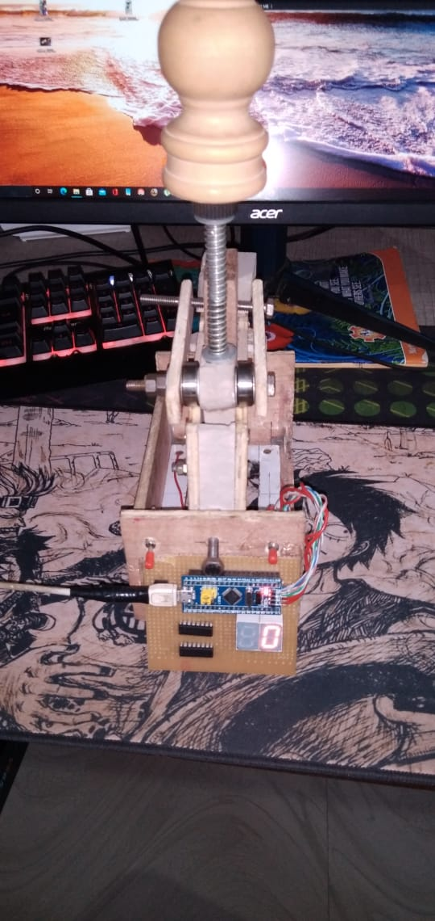

**3 Hardware Setup**

**3.1 General Wiring**

Appendix B shows the technical wiring diagram of the complete OpenSimwheel package. Credits go to Beano for creating this diagram. Due to high currents of the servo power cable, try to separate it from all other cables. Use shielded cables and ferret cores for the servo feedback cable. In case of using an aluminum profile rig and problems still occur, try to ground the rig.

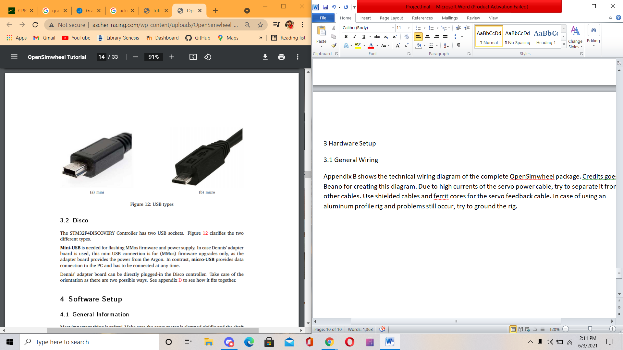

**3.2 Disco Board(brain of system stm32f407 )**

The STM32F4DISCOVERY Controller has two USB sockets

**Mini-USB** is needed for flashing MMos firmware and power supply. In case Dennis’ adapter board is used, this mini-USB connection is for (MMos) firmware upgrades only, as the adapter board provides the power from the Argon. In contrast, micro-USB provides data connection to the PC and has to be connected at any time.

Dennis’ adapter board can be directly plugged-in the Disco controller. Take care of the orientation as there are two possible ways. See appendix D to see how it fits together.

**4 Software Setup**

**4.1 General Information**

Most important thing is safety! Make sure the servo motor is clamped rigidly and the shaft can spin without destroying anything (e.g. no coiled cable from rig to wheel). Be always prepared for the wheel to rev up or oscillate. If something unexpected happens, don’t grab the wheel by reflex but use the STO3 (emergency switch) instead. Read carefully and follow the instructions step by step as described in following sections. There is a known incompatibility of the MMos FFB Tool with vJoy and Bodnar controllers. This FFB tool is only needed to set up the wheel or making changes (e.g. damping), not for actual driving (you can then use your Bodnar controllers of course). In this case, simply unplug all controllers when using MMos FFB Tool. If vJoy is installed on your computer you’ll have to uninstall it

.

**4.2 Required Software**

These programs, drivers or firmware’s are required:

1. Granity

2. STM32 ST-LINK utility

3. MMos FFB

4. Virtual COM Port driver

5. Visual C++ Redistributable

6. Argon core firmware

7. Argon I/O firmware

8. motor settings file

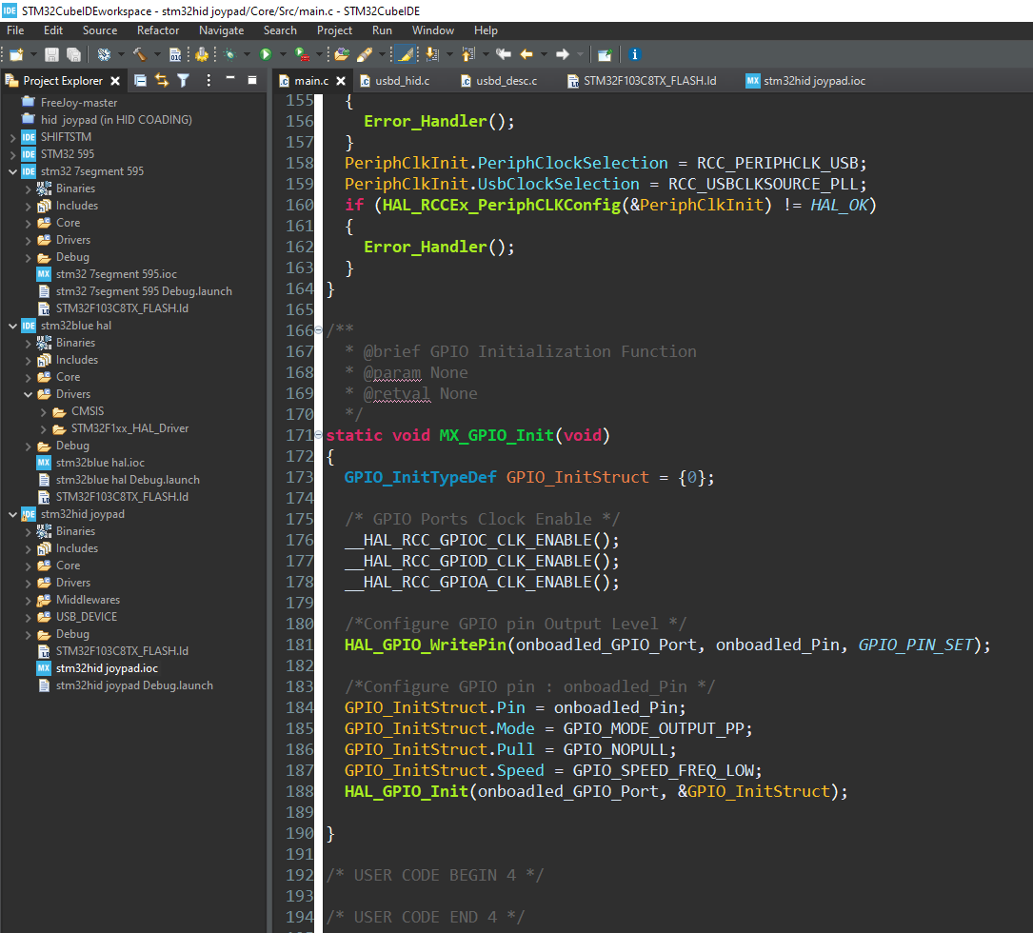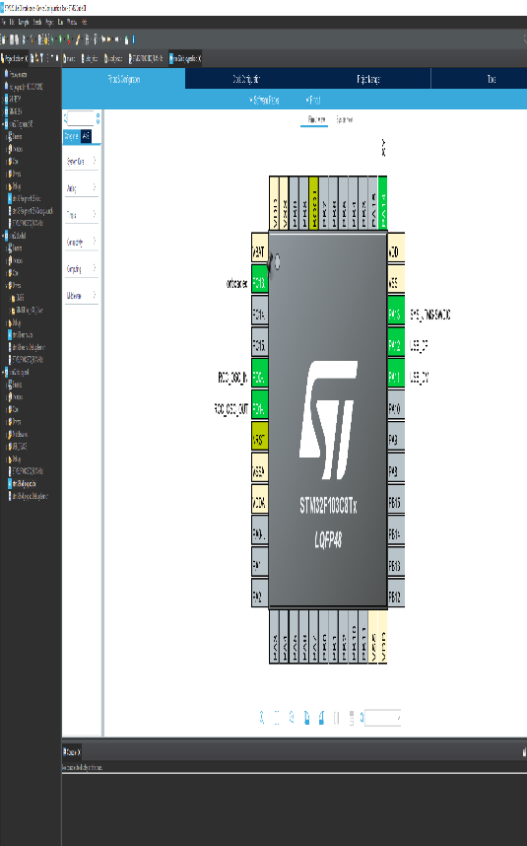

**4.3 Granity**

This section guides through setting up Argon with Granity software. The drive stage has DIP-switches (see figure 13) to set the device address that identifies the device on a multidrop communication bus. In our case, we need this to change between normal operation and firmware upgrade mode. Set the DIP-switch as follows:

* normal operation 00011 (device adress 1)
* rmware upgrade 00001 (device adress 255)

1. download Granity software

2. extract the files to a new folder and start the program by clicking Granity.exe.

3. set Argon DIP-switches to firmware upgrade mode

4. connect Argon and PC via RJ45 patch cable and Simple Motion V2 adapter

5. Windows recognizes it as a serial port normally; if not install the Virtual COM Port driver manually

6. power on the Argon

7. Connect Tab → select the SMV adapter

8. connect

9. select Argon at adress 255

10. select core firmware

11. restart Argon

12. select Argon at adress 255

13. select I/O firmware

14. turn off Argon

15. set device adress 1 (DIP 00011)

16. turn on Argon & connect

17. load settings from file

18. select motor setting drc-file

19. save settings to drive

20. disconnect.

This are not the final settings and will be changed after MMos FFB is installed to the Disco controller

If a braking resistor is used the Granity FOV6 parameter needs to be increased. Otherwise, the Argon would constantly heat the resistor, even without load!

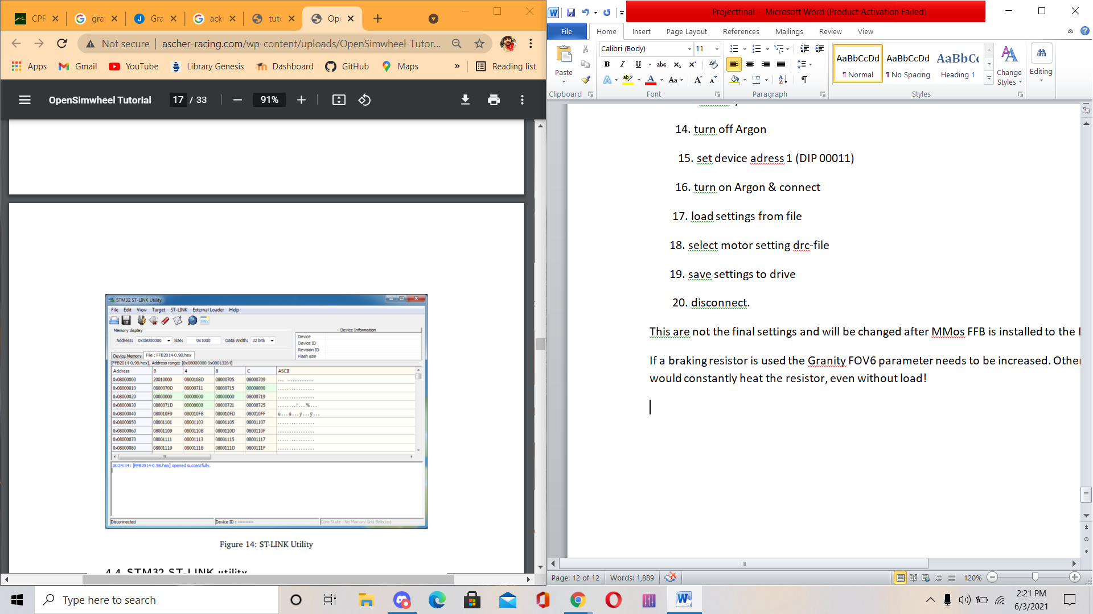

**4.4 STM32 ST-LINK utility**

This software is required to flash the MMos FFB hex-file to the Disco controller board. See figure 14 for screenshots.

1. connect mini-USB cable to Disco board

2. install STM32 ST-LINK utility.

3. connect

4. erase chip

5. program and verify

6. select MMos hex-file

7. start flashing

8. disconnect

9. unplug mini-USB cable.

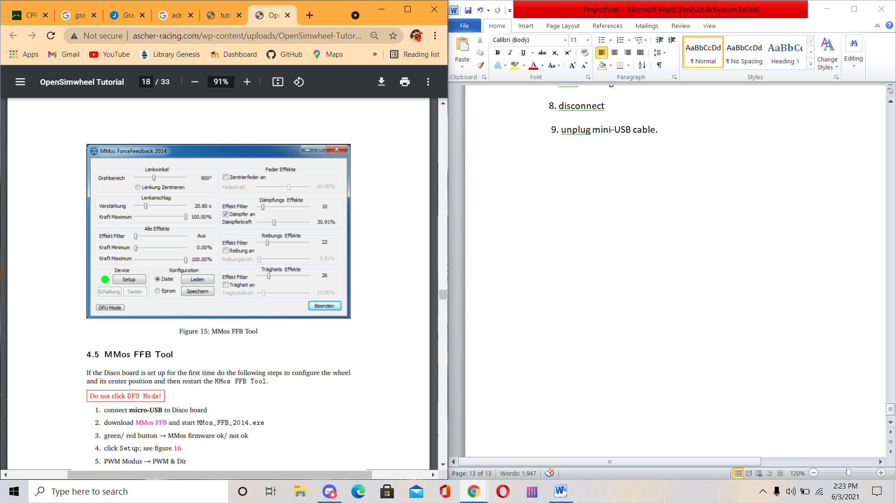

**4.5 MMos FFB Tool**

If the Disco board is set up for the first time do the following steps to configure the wheel and its center position and then restart the MMos FFB Tool.

Do not click DFU Mode!

1. connect micro-USB to Disco board

2. download MMos FFB and start MMos_FFB_2014.exe

3. green/ red button → MMos firmware ok/ not ok

4. click Setup; see figure 16

5. PWM Modus → PWM & Dir

6. PWM Frequenz → 3.4 kHz

7. Encoder CPR: MiGE/ Lenze → 10 000/ 16 384

8. Index auswerten → tick

9. Tasten 1-16 → STM32 Pins

Now, switch off the Argon and Disco to see what the initial startup is like. Once under power, the wheel starts to oscillate carefully to initialize itself. It’s called phasing and after about 20 s a clicking sound indicates phasing finished. The Disco shows a blue LED flashing which means that it waits for you to turn the wheel until the index is found. Once you’ve done this, the LED turns off and the wheel is

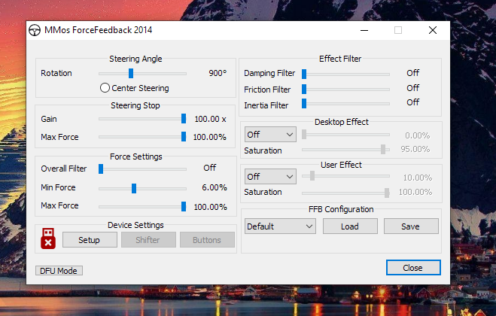

**4.6 Tuning Torque Controller**

This section shows how to fine tune the Argon torque controller for optimal performance. This means finding the correct gain values for the torque controller inside the Argon to achieve a proper response from a torque setpoint change. Visit the official Granitedevices Wiki for a step by step manual.

These gain values, namely MR and ML , can be taken from the motor datasheet. Due to manufacturing tolerances these parameters may not be quite accurate hence testing can increase the overall performance.

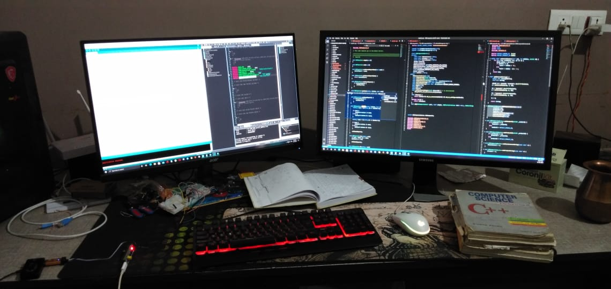

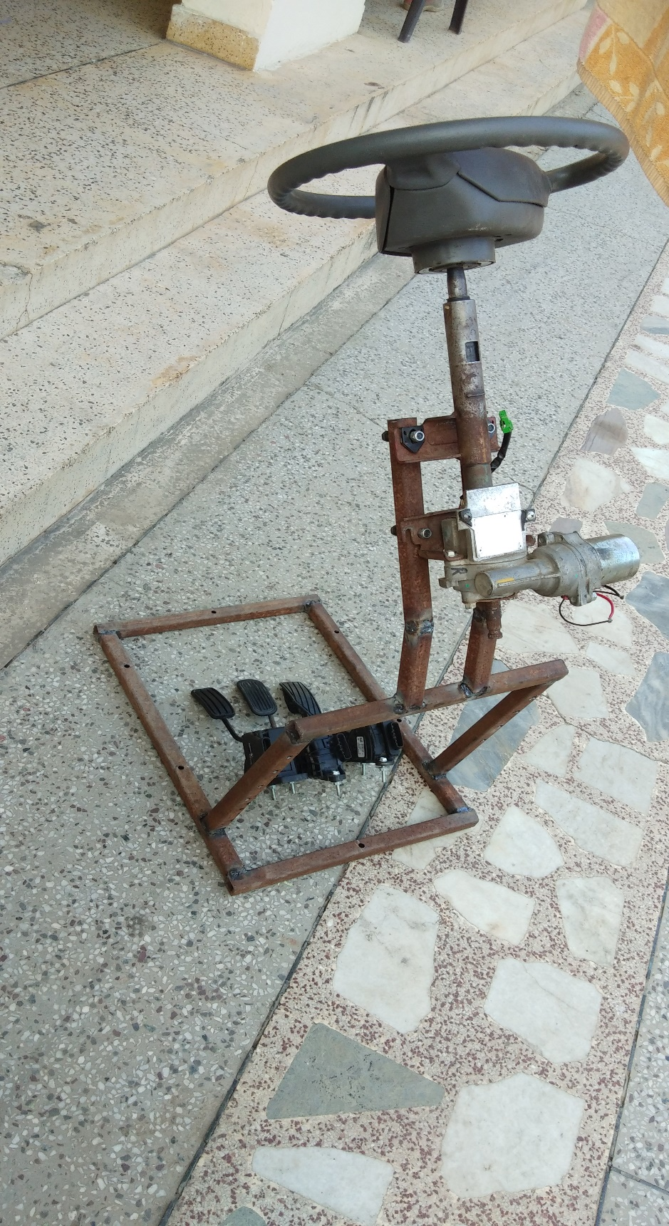

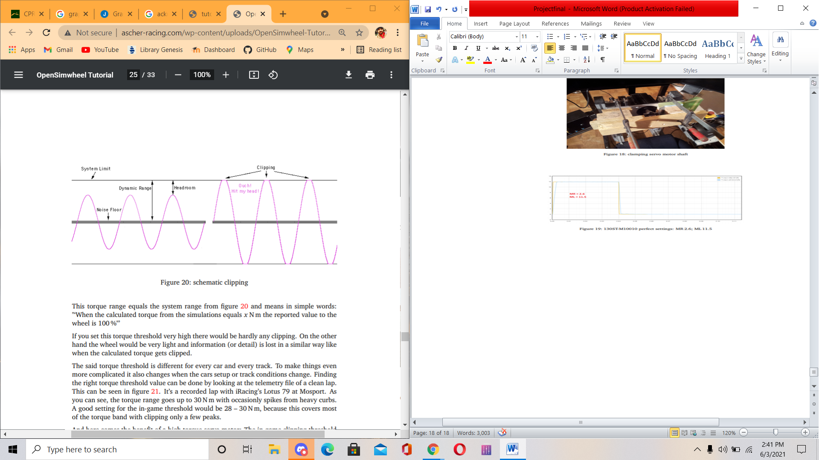

This torque range equals the system range from figure 20 and means in simple words: "‘When the calculated torque from the simulations equals x N m the reported value to the wheel is 100 %"’ If you set this torque threshold very high there would be hardly any clipping. On the other hand the wheel would be very light and information (or detail) is lost in a similar way like when the calculated torque gets clipped. The said torque threshold is different for every car and every track. To make things even more complicated it also changes when the cars setup or track conditions change. Finding the right torque threshold value can be done by looking at the telemetry file of a clean lap. This can be seen in figure 21. It’s a recorded lap with iRacing’s Lotus 79 at Mosport. As you can see, the torque range goes up to 30 N m with occasionly spikes from heavy curbs. A good setting for the in-game threshold would be 28 – 30 N m, because this covers most of the torque band with clipping only a few peaks. And here comes the benefit of a high torque servo motor: The in-game clipping threshold is set to the servo’s peak torque. That means all torques (people often refer to force) are mapped 1:1 and are not scaled. But this only works if the maximum servo torque is high enough compared to the simulated steering rack torque by the game physics engine.

It’s easier with numbers:

• car example requires 19 N m at maximum lateral acceleration

• in-game torque threshold set to 19 N m means that the simulations reports 100 % of "‘force"’ when reaching 19 N m

• wheel F is capable of maximum 7.3 N m. It delivers this amount of torque when the simulations reports 19 N m in-game. It’s scaled by 1:2.6

• wheel O is capable of maximum 19 N m and is scaled 1:1.

During a slow turn only 5 N m are requested by the simulation.

• wheel F would scale this value and only 5/2, 6 = 1.92 N m are output by the wheel

• wheel O would output true 5 N m as it’s unscaled .

That’s the next advantage of a strong direct drive wheel. It’s not about the peak torques and bashing over curbs. It is the enhanced detail which is perceived at low forces.

On top there is a large headroom for high peaks which makes the whole force feedback experience more believable. Imagine racing at the peak lateral acceleration through a corner. When hitting the curb at the apex, this additional torque can be felt at the steering wheel. A low powered wheel at a lower clipping range would output 100 % in both situations: before and during hitting the curb, hence it is not felt in the wheel.

Setting this torque threshold explicit in-game is only possible with iRacing (as far as I know). To do this, simply change a setting in the iRacing’s app.ini (my Documents). Set DisplayLinearInNm = 1 in order to change the FFB-slider from the uniteless number to a torque value in N m.

See figure 22 for a correlation between these two methods. Horizontal axis is the value of the normal iRacing FFB slider; vertical axis is the value in N m when set the app.inisetting to DisplayLinearInNm = 1.

**4.7. Circuit layout**

s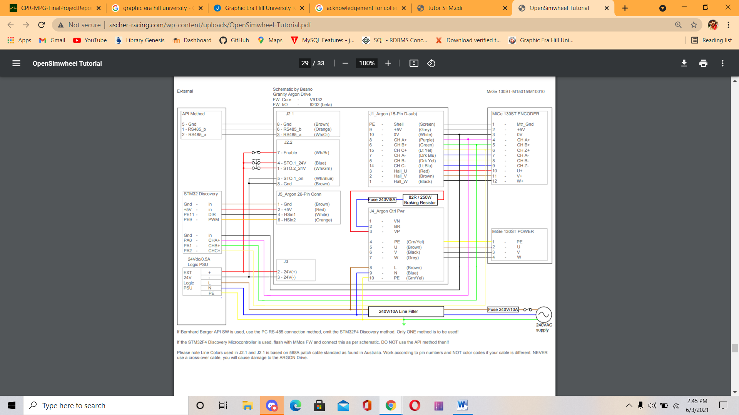

**Disco Adapter Board Connections**

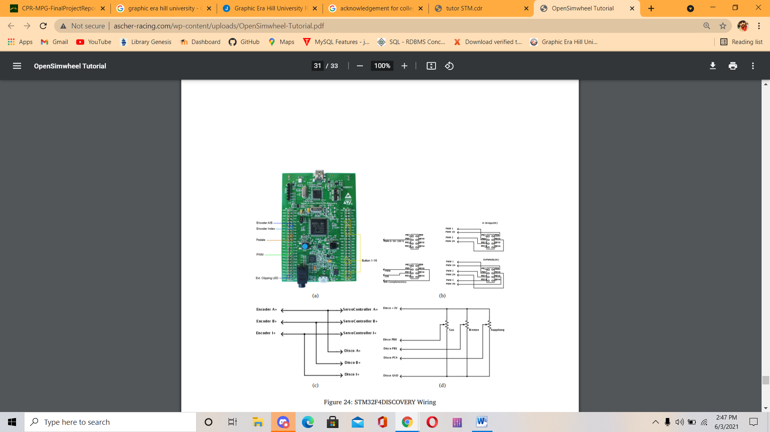

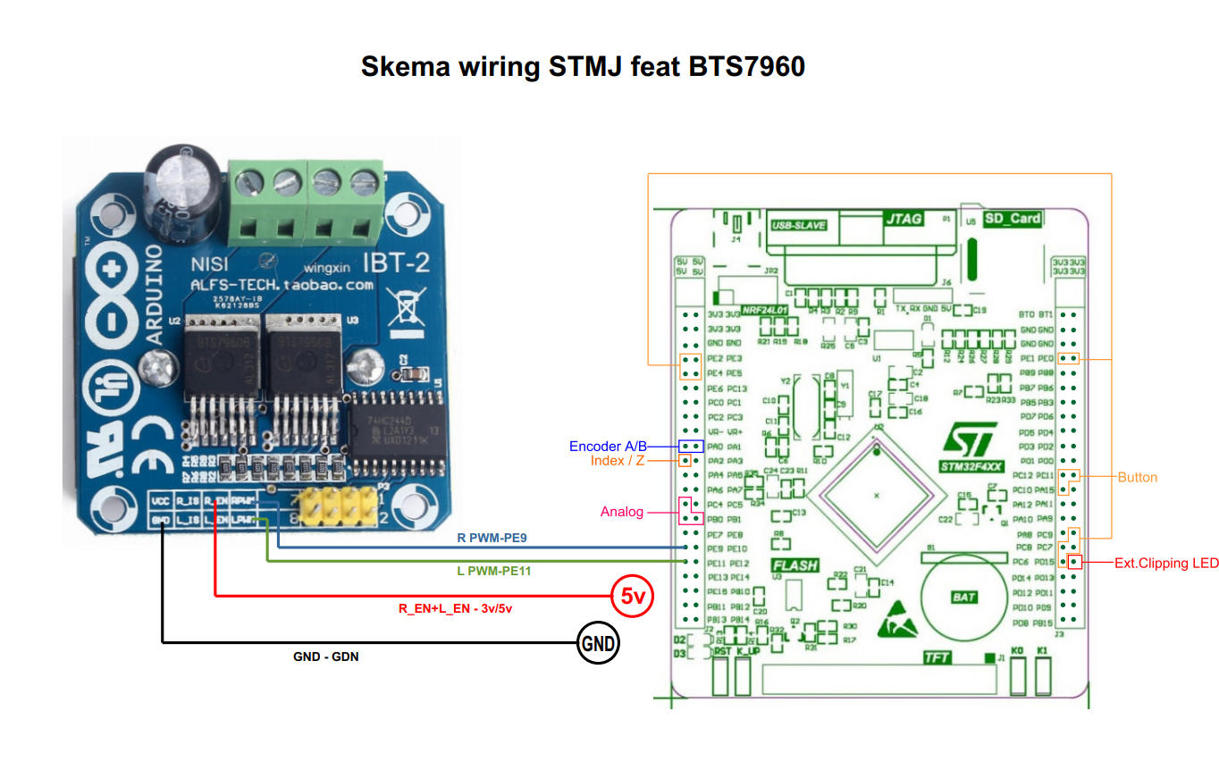



**Project photos**

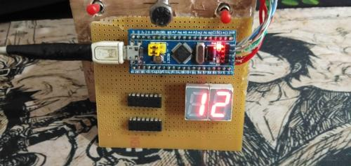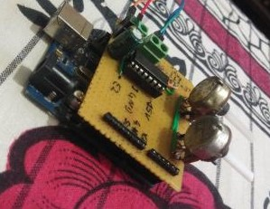

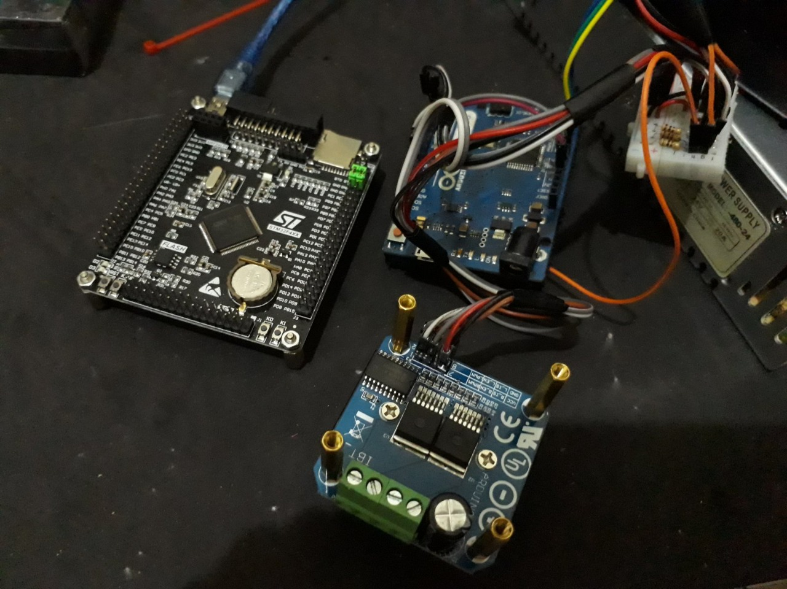

**REFERENCES**

* <https://www.xsimulator.net/community/threads/how-to-make-a-diy-racing-wheel.7403/>
* https://hackaday.io/project/168801-diy-mmos-ffb-stm32-and-servo-drive-servo-motor
* mmos forcefeedback 2014
* <https://www.st.com/en/development-tools/stsw-link004.html>
* <https://forum.virtualracing.org/threads/diy-usb-force-feedback-controller.92420/>
* https://forum.virtualracing.org/threads/diy-usb-force-feedback-controller.92420/